

Rap as a service – Guide for customers



**Dynamics CRM**

Prepared for Dynamics CRM Rap as a Service customers

24-Mar-2015

Version 1.4

Prepared by

Fadi EL-Hennawy and Julien Clauzel

# Table of content

Table of content 2

“Rap as a Service” key objectives 4

Global process overview 4

Prerequisites 4

In case of errors while performing data collection 5

Immediately reach out to the TAM and PFE. If needed opens an User Voice ticket 5

On the day of “Rap as a Service” delivery 5

What do we collect? 5

Building blocks “Rap as a Service” 5

Prerequisites Script (Mandatory) 6

Checks performed 6

Usage 6

Example 7

Performing tool machine local tests. 7

Analyzing tool machine configuration. 7

Performing remote tests on CRM Servers and including SQL sysadmin role check 7

Performing remote tests on CRM Servers and including SQL sysadmin role check 7

Overall summary results (with Error) 8

Overall summary results. (with no errors) 9

WMI robustness check 9

The Objective from running the scoping tool 9

*Verifying that the user running the script has the SQL Server SYSADMIN role* 10

*Next step* 11

Collect phases using the “Rap as a Service” client for CRM 12

Best practices 12

If tools machine does not have Internet access 12

« Known issues » 12

Do we have a « good enough » data collection? 13

Deliverables 14

Annexes 14

MICROSOFT MAKES NO WARRANTIES, EXPRESS OR IMPLIED, IN THIS DOCUMENT.

Complying with all applicable copyright laws is the responsibility of the user. Without limiting the rights under copyright, no part of this document may be reproduced, stored in or introduced into a retrieval system, or transmitted in any form or by any means (electronic, mechanical, photocopying, recording, or otherwise), or for any purpose, without the express written permission of Microsoft Corporation.

Microsoft may have patents, patent applications, trademarks, copyrights, or other intellectual property rights covering subject matter in this document. Except as expressly provided in any written license agreement from Microsoft, our provision of this document does not give you any license to these patents, trademarks, copyrights, or other intellectual property.

The descriptions of other companies’ products in this document, if any, are provided only as a convenience to you. Any such references should not be considered an endorsement or support by Microsoft. Microsoft cannot guarantee their accuracy, and the products may change over time. Also, the descriptions are intended as brief highlights to aid understanding, rather than as thorough coverage. For authoritative descriptions of these products, please consult their respective manufacturers.

© 2014 Microsoft Corporation. All rights reserved. Any use or distribution of these materials without express authorization of Microsoft Corp. is strictly prohibited.

Microsoft and Windows are either registered trademarks or trademarks of Microsoft Corporation in the United States and/or other countries.

The names of actual companies and products mentioned herein may be the trademarks of their respective owners.

# “Rap as a Service” key objectives

* Identify what are the « top » potential issues that should be remediated if applicable.
  + Note: Customer owns the remediation if applicable. Remediation is not included in this service.
  + There are two key metrics being used in “Rap as a Service”: **health (now)** and **Risks (issues that may potentially happen in the future if not remediated)**.
* There are three key deliverable (Doc, PPT and Excel) in English only.
* Customer can run the “Rap as a Service” client at his own pace for a year (starting initial download time) and evaluate how the platform evolves as well as the remediation action impact.
  + Note: Rap as a Service offline is a one time delivery and the tools expires shortly after collection.

# Global process overview

## Prerequisites

* **Customer** reads the prerequisites document.
* Customer deploys the tools machine and implements all the prerequisites.
* **Customer verifies that all the prerequisites are in place as quickly as possible with the [prerequisites script](#_Prerequisites_Script_(Mandatory))**. If any issue occurs:
  + Customer making sure all prerequisites are in place.
  + If error persists open a UV support ticket, notifies the TAM/SDM.
    - See section “In case of errors…” below

**ALL prerequisites must be in place and [prerequisites script](#_Prerequisites_Script_(Mandatory)) must returned “PASSED” prior running the “Rap as a Service” client tool**. Some “Warning” may be acceptable and a “good enough” data collection may be archived.

* Customer downloads the “Rap as a Service” client including the key from the services portal (note there is a **10 days expiration token time frame** so customer should download within this time frame after engagement has been provisioned).
  + Note: If a previous “Rap as a Service” client or Offline “Rap as a Service” client is installed on the tools machine it needs **to be uninstalled first** and the “Documents” /Rap as a Service” folder of the user running the data collection needs to be renamed to “Rap as a Service Previous”.
* Customer fills in the online survey: it is common that the customer needs to sub dispatch some questions to several internal team so he needs to start performing this activity as quickly as possible (for example to infrastructure teams, backup teams, dev teams/partner …).
* Customer performs a first initial test data collection (plan 4h30). The idea here is to make sure that there are no key issues found during data collection and if yes to fix them as quickly as possible.
* Once the first test data collection has been performed the customer renames the “Documents” « Rap as a Service » folder in « Rap as a Service_old ». The aim is to have the best data collection as possible and possibly get rid of all previous errors he might have had due to missing prerequisites.
* Customer runs the second data collection **at peak load** the next day and submits the data.
* **Once the data has been submitted he notifies the TAM/SDM and PFE**.
* TAM plans the « closing call » with the customer and PFE.
  + Throughout the conference call we will go to the findings and start discussing the remediation plan if needed. This is allows to define post services if applicable.
    - TAM then drives the RPS discussion throughout the conference call.

## In case of errors while performing data collection

### Immediately reach out to the TAM and PFE. If needed opens an User Voice ticket

[http://PPAS.uservoice.com](http://ppas.uservoice.com/)

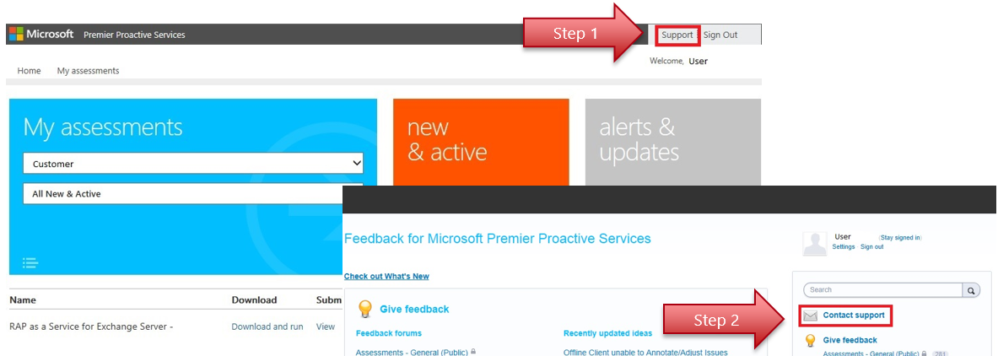

## On the day of “Rap as a Service” delivery

* Morning: PFE analyses the data collected and generates the various deliverables (Word key findings document, PowerPoint assessment results presentation and Excel risk & health issue list).
* Afternoon: PFE & TAM/SDM prepare 1:1 the closing conference call / RPS (Remediation Planning Session).
* Evening: PFE + TAM + Client « Closing Conference Call ».
* Engagement concluded, Remediation planning starts with TAM/SDM.

# What do we collect?

* The following key vital signs of the below components are collected:
  + Windows,
  + SQL,
  + IIS,
  + CRM

The data collection is « non-intrusive» as most of it is sequential and based on several years of feedback and experience on CAVE (Collection Analysis & Visualization Engine). We do not change anything.

Impact on production is minimal. That is for this specific reason as well we request a tools machine to reduce as much as possible the impact on the existing CRM workload.

Data transfer between “Rap as a Service” client and the Premier services Portal is encrypted and secured. In the specific case of Offline “Rap as a Service” no data is transferred to Microsoft.

## Building blocks “Rap as a Service”

The Dynamics CRM “Rap as a Service” relies on the following standard « Building Block »:

* Windows,
* SQL,
* IIS (this is currently a different version from the IIS “Rap as a Service” with Dynamics CRM-IIS own rules).
* CRM building block. Some of its rules rely on the data collection of the three above collectors.

The “Rap as a Service” « discovery » service code is specific to CRM and discovers the following roles: Windows (including IIS), SQL Server and Dynamics CRM server components.

Note: **The Email router is not discovered** and we have no specific rule currently targeting it. If you know that there are specific issues related to it please let your TAM/SDM **know about them and they should be able to recommend you the best course of action.**

# Prerequisites Script (Mandatory)

## Checks performed

The scoping tool, is a VBS script that verifies your tools machine to check if it is ready for collecting the data, and all needed prerequisites are in place for using RaaS Client tool.

The VBS script also uses a TestPort.ps1 PowerShell script that is executed as part of the analysis. The TestPort.ps1 script must be deployed in the same directory as the VBS script.

Script is divided into three phases:

* Phase 1 and 2 - Verification of prerequisites on the machine tool itself.
* Phase 3 - Check that the machine tool can: connect to different servers, checking privileges, the IIS logs are active, etc ...

At the end of each phase and at the end of the script the number of errors is summarized.   
Two log files are generated (CRMRap as a ServicePreReqsFailuresLog.txt and CRMRap as a ServicePreReqsScriptLog.txt) located in the same directory where the tool is located, and can be shared with the TAM or PFE if needed.

## Usage

From a command line, with privileged permission the (run as administrators) script as follows:

|  |  |
| --- | --- |
| Scenario | Command line |
| For a simple deployment where everything is consolidated on a single server. | Cscript VerifyCRMRap as a ServicePreReq-*Version*.vbs frontcrmserveur |
| More complex deployments over more than one server repeat the steps for every servers.  Note: If sql server is deployed on a cluster, the sysadmin check must pass at least once on the named instance or primary node. | Cscript VerifyCRMRap as a ServicePreReq-*Version*.vbs frontcrmserveur1 Cscript VerifyCRMRap as a ServicePreReq-*Version*.vbs frontcrmserveur2  Cscript VerifyCRMRap as a ServicePreReq-*Version*.vbs serveursql1  Cscript VerifyCRMRap as a ServicePreReq-*Version*.vbs serveursql2 |

## Example

Output is divided in 4 sections:

### Performing tool machine local tests.

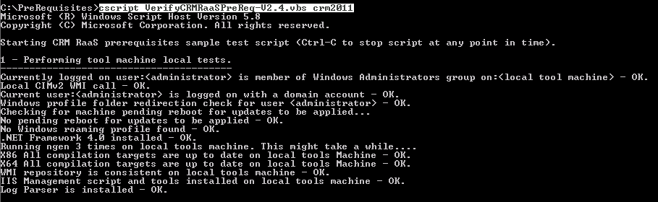

### Analyzing tool machine configuration.

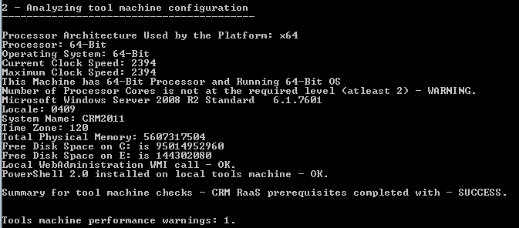

### Performing remote tests on CRM Servers and including SQL sysadmin role check

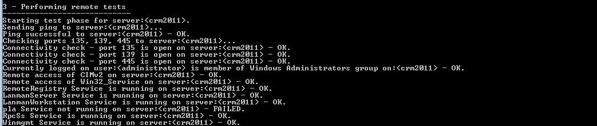

### Performing remote tests on CRM Servers and including SQL sysadmin role check

Note: **user Input is required**

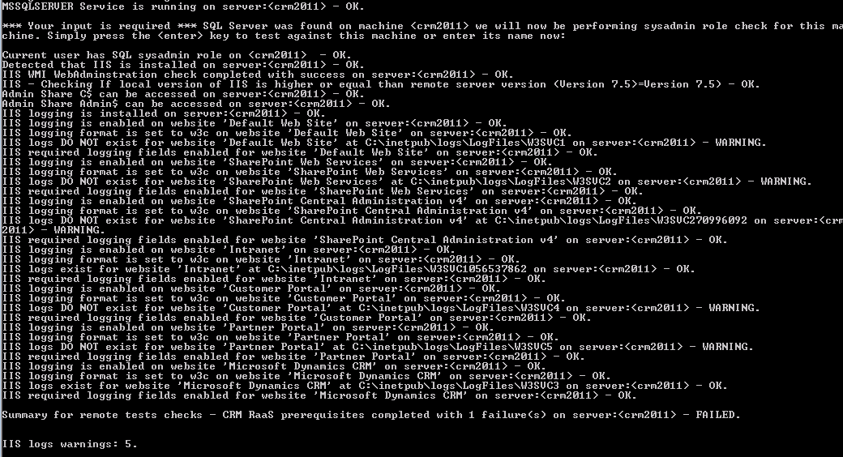

### Overall summary results (with Error)

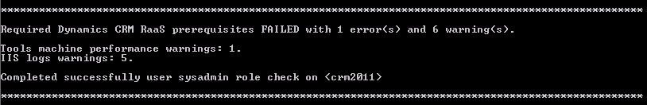

If look in greater details we had:

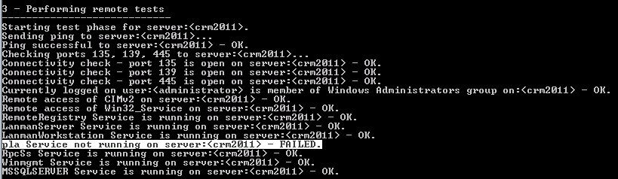

Always attempt solving all errors until “PASSED” is displayed in the overall summary results section.

Here we start the pla service from an elevated cmd shell.



### Overall summary results. (with no errors)

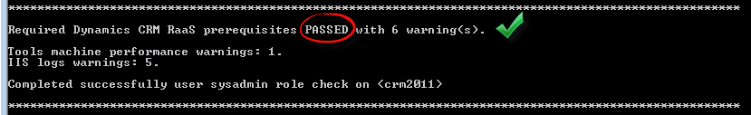

By default the script will detect when a server has SQL Server installed and started, then will ask for user input to verify that the user has sysadmin rights on the SQL Server.

"*** Your input is required *** SQL Server was found on machine <crmfrontcontoso> we will now be performing sysadmin role check for this machine”.

On a simple non-clustered configuration it is usually sufficient to press “Enter” at the question.

When SQL Server is deployed on a different machine please enter machine name.

In more complex scenarios where SQL Server is deployed on a different Machine, please enter the SQL Server instance name.

If you don’t know the SQL Server machine/instance name, please check with your DBA.

**It is absolutely necessary to successfully complete this prerequisite test.** This is often problematic in complex organizations or DBA’s have not given this privilege to administrators CRM. It is therefore necessary to perform this test as soon as possible in case of need to request a temporary waiver from SQL teams.

## WMI robustness check

By default the script performs WMI robustness check. If needed it can be disabled by setting bSkipWMIRobustness to true inside the script itself as shows bellow:

|  |
| --- |
| Example |
|  |

# The Objective from running the scoping tool

The ideal solution is to get to the end of the script execution requirements:   
Required Prerequisites Dynamics CRM Rap as a Service PASSED with 0 warning (s).

Although "Passes with Warning", is ideal it does mean that we have a collected sufficient data. It is therefore necessary to work with the prerequisites to obtain at least "Required Prerequisites Dynamics CRM Rap as a Service" PASSED ". Verifying that the user performing the collection has sysAdmin rights on the CRM database instance

Once the tool returns no errors and shows a status of “PASSED" the installation of the tool-Rap as a Service can be done and the collection of results can start.

|  |  |
| --- | --- |
| **Sample summary output with failures at end of script** | **Sample summary output with failures PASSED at end of script** |
| Required Dynamics CRM Rap as a Service prerequisites **FAILED** with 1 error(s) and 6 warning(s).  Tools machine performance warnings: 1.  IIS logs warnings: 5. | Required Dynamics CRM Rap as a Service prerequisites **PASSED** with 0 warning(s).  **Completed successfully user sysadmin role check on** <crm2011> |

# Verifying that the user running the script has the SQL Server SYSADMIN role

The following example shows how to verify that the account CONTOSO \ Administrator does have the sysadmin rights.   
Opened SQL Management Studio -> Open "Security" -> right click "Property" on the target account -> Browse "Server Roles" tab "sysadmin" group must be checked.

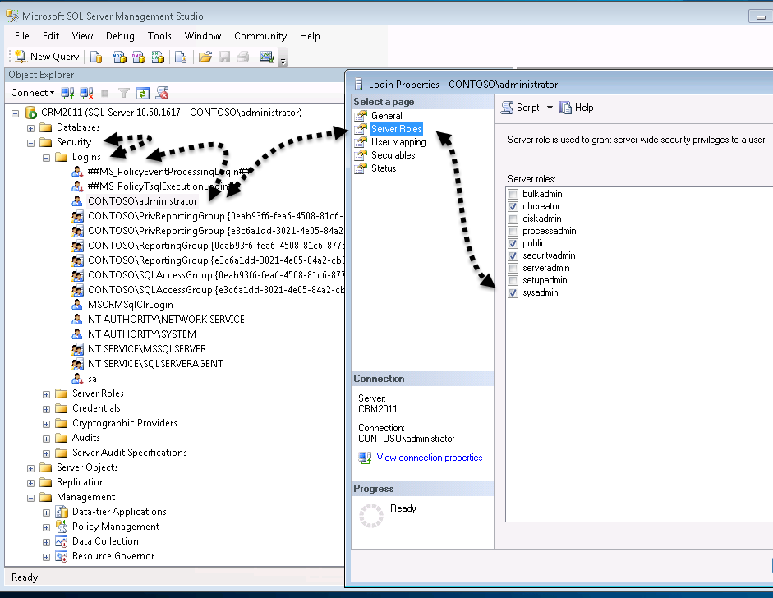

* If the account does not appear in the list or sysadmin does not appear. It is possible that the account you use to log on does not have sufficient privilege to SQL to see the rights of certain users. -> Contact DBA
* If the account appears in the list but does not have the “sysadm” role checked, grant the account “sysadm” rights or contact the DBA to do so.

# Next step

Run the “Rap as a Service” Client Tool.

# Collect phases using the “Rap as a Service” client for CRM

“Rap as a Service” Client install is simple (MSI simple, « next, next »), the “Rap as a Service” client only verifies some basic prerequisites for the engine itself in this case if: Framework .NET 4.0 is installed.

This does not mean that CRM prerequisites are met this is why using the prerequisites script is so important. The prerequisites script is currently the best method to verify they are met

When the “Rap as a Service” Client is first started:

* + The user needs to input the name of a CRM application frontend server. This allows the « discovery » of all the servers in the environment related to CRM (SQL, CRM, IIS…). Note: the email router as detailed earlier on in this document is not discovered.
  + The data collection is then performed in two phases : configuration & settings then performance counters

|  |  |
| --- | --- |
| Collection phase | Average time |
| Configuration & settings | 10 minutes |
| Performance counters | 4h |

## Best practices

* Always try to execute the “Rap as a Service” client when there is expected peak load for example first half of the evening.
* When a first data collection has been performed without any major collector failure due to missing prerequisites, rename the « Rap as a Service » folder in the user “Documents” folder to « Rap as a Service_old » and the next day at same peak load perform an new data collection.

## If tools machine does not have Internet access

At the end of data collection choose the option to package and provide key.

Install the “Rap as a Service” client on a machine that has internet access and then choose the « upload » option and provide the key.

# « Known issues »

* Some errors may occur while collecting IIS logs and some IIS collectors may fail. (They usually should have triggered some prerequisites tools warning) – Let your PFE know but these errors may not block from delivering and data collection should be “good enough”.
  + You can move forward & submit data in most cases.
* Log Parser install missing causing IIS collector errors.
* « IIS script and tools » missing causing IIS collector errors.
* Some CRM installation create a specific IIS new site such as CRM Web site and leaves the IIS “Default Web Site” empty. This causes IIS collector errors because there are no logs available for the “Default Web Site”. This can be safely ignored.
* Users with Windows roaming profiles, locally cached profiles, or folder redirection are not supported and cause errors.
* Customers often miss many perquisites, **don’t wait to use the prerequisites script.**
* When error occurs during data collection :
  + Close “Rap as a Service” Client.
  + Rename the « Rap as a Service » folder in the user “Documents” folder to « Rap as a Service_old »
  + Start a new data collection.
* The version of the OS (and IIS) on the tools machine must be equal or higher that the targeted CRM Server version (especially for IIS).
* The tools machine **must be domain joined in the same domain of the CRM servers**.
* The user account performing data collection must be a **domain** account.
* The user account used to logon on the tools machine **must not log on locall**y (with a local account). The account used must be a **domain account** (mirrored local accounts with same login passwords are not supported).
* The domain account used to logon on the tools machine **must be part of the local administrator group on all machines including tools machine.** We have some checks for this in prerequisites script though it will not work for languages such as Chinese, Russian, Hebrew, Greek as this was too complex to implement short term.
* Some firewalls or customizations performed to Windows Firewall may block RPC/SMB, having WMI working properly between Rap as a Service client and each server is a “must have”. The prerequisites script extensively test/ rely on that, so use it as soon as possible in the delivery process.
* Internet access is required to submit data from “Rap as a Service” client to the premier service portal. If the “Rap as a Service” client can’t access directly the internet you’ll need to deploy a temporary client that has access, though again the internet access may go through blocking proxies that provide limited access by applying all sorts of filtering.
* If a previous “Rap as a Service” client is already installed on the tools machine, uninstall it first don’t try to reuse it. Rename the previously generated « Rap as a Service » folder in the user “Documents” folder to « Rap as a Service_previous ».
  + Download on regular basis new “Rap as a Service” client from the premier services portal. The “Rap as a Service” client does not self “Windows Update” you need to download the latest bits to get the set of rules/checks (if they have been updated in the meanwhile).

# Do we have a « good enough » data collection?

Having a « good enough » data collection doesn’t mean we have no failing collectors. It means we have enough significant data to detect the possible top issues that needs to be addressed first.

The **Customer** is the driver of the data collection and it is his responsibility to make sure the prerequisites script is ran as soon as possible. This to make sure that all prerequisites are in place and data collection is completed.

**The data collection and survey must be completed a minimum of two week prior the analysis begins**, **don’t wait to use the prerequisites script.**

Failing IIS collectors are usually caused by:

* Log Parser missing on tools machine,
* « IIS script and tools » components missing.
* Large IIS log files.

# Deliverables

* Word report in English only.
  + This document is only generated once by the PFE (the customer doesn’t have the option to generate its own).
* PPT document containing the score card and top issues identified is presented during the closing conference call.
* The Excel document with all issues triggered by the platform.

# Annexes

* Premier Services portal: <https://services.premier.microsoft.com/>
* The following URIs should be allowed/reachable without filtering through proxy servers for “Rap as a Service” client to submit data :
  + <http://corp.sts.microsoft.com>
  + <http://live.com>
  + <http://login.live.com>
  + *.accesscontrol.windows.net